Cloud Computing
- Characteristics: On-demand self-service, broad network access, resource pooling (multi-tenancy), rapid elasticity, measured service (pay-as-you-go)
- Service models: SaaS, PaaS, IaaS
- Models: private, community, public, hybrid
- Failure points web service: application bugs, deployment failures, scalability issues, infrastructure failures, monitoring gaps, security vulnerabilities
- Container use challenges: cultural changes, lack of training, security, CI/CD, monitoring, complexity

DevOps
Cultural mindset, Automation-first approach, Continuous processes, Monitoring & feedback loops, Rapid & reliable releases, Security
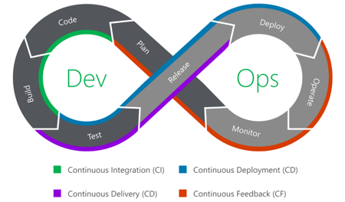
- Plan: requirements, stories creation, architecture, metrics & alerts analysis, risk & rollback strategy
- Code: local builds & tests, reviews, gated merges
- Build: compile source, create container images, publish artifacts to a registry, generate versioned release packages, store build metadata for traceability
- Test: automated unit, integration, E2E, performance & load testing, security/vulnerability scanning, code coverage, quality gates, publish test reports
- Release: promote verified artifact to release repository, assign immutable version, publish release notes and notify stakeholders, store release metadata (build ID, commit SHA, artifact hash) for traceability
- Deploy: Pull released artifact from repository into target environment, apply deployment manifest, execute deployment strategy, provide / trigger automated rollback if validation fails
- Operate: Document, troubleshoot, scale, apply security patches, rotate secrets, manage configuration drift, backup & restore, compliance
- Monitor: Define service-level indicators (SLIs) & service-level objectives (SLOs), dashboards, alerting rules, health checks, logging, metrics and traces

Continous Lifecycle
- Continous development: Plan & Code
- Continous integration: Code, Build & Test
- Continous Testing: Test
- Continous Delivery: Test & Release
- Continous Deployment: Test, Release & Deploy
Strategies: Rolling deployment: update gradually to minimize downtime, Blue green: two environments for fast switching, Canary release: specify user group to deploy to first, Feature flags: deploy but activate later, Dark Launching: use real user traffic but hide it
- Continous Feedback: Operate, Monitor & Plan

Platform Engineering
- Cultural mindset to build internal platforms that allow efficient delivery of applications
- Core responsibilities: enable self-service, standardize runtimes & tooling, abstract infrastructure, enforce compliance & security, provide observability
- Typical building blocks from bottom to top: compute & orchestration, IaC, Pipelines, Deployment, Package & Artifact Management, Policy & Security, Observability, Cost & Capacity, Self-service portal

CI/CD
- A pipeline is a series of automated steps that helps teams deliver code faster, safer and more reliably
- Faster feedback loops - higher quality
- Reduce manual effort - fewer human errors
- Consistent environment - no “works on my machine”
- Parallel jobs - scalability to process many commits
- Logged pipeline output - traceability for audits
- Increased efficiency – cost savings
- Enables continuous delivery and deployment
Concept | Purpose
Stage | Logical grouping of jobs  stages: [build, test, deploy]
Job | Atomic unit of work that runs inside a stage  <job_name>: { stage: build, script: [...] }
Step | Individual commands/scripts of a job  script: ["cmd1", "cmd2"]
Rule | Controls when a job runs (branch filters, tags, manual triggers, schedules)  rules: [ { if: ..., when: ... } ]
Service | Auxiliary containers/services (database, Docker-in-Docker) that run alongside a job  services: [{name: "postgres:15", alias: "db"}]
Runner | Compute resources that execute jobs  tags: ["my-mac-runner"]
Cache | Temporary storage that speeds up repeated work (dependency downloads, compilates)  cache: { key: "...", paths: ["$HOME/.cache"] }
Artifact | Files produced by a job that are persisted for later stages or for download by users  artifacts: {paths: ["bin"], expire_in: "1 week"}
Registry | Stores for built images or packages  script: ["docker login …", "docker build …", "docker push …"]
Variable | Key-value pairs (plain or masked) injected into jobs for configuration or credentials  variables: {FOO: "bar"}

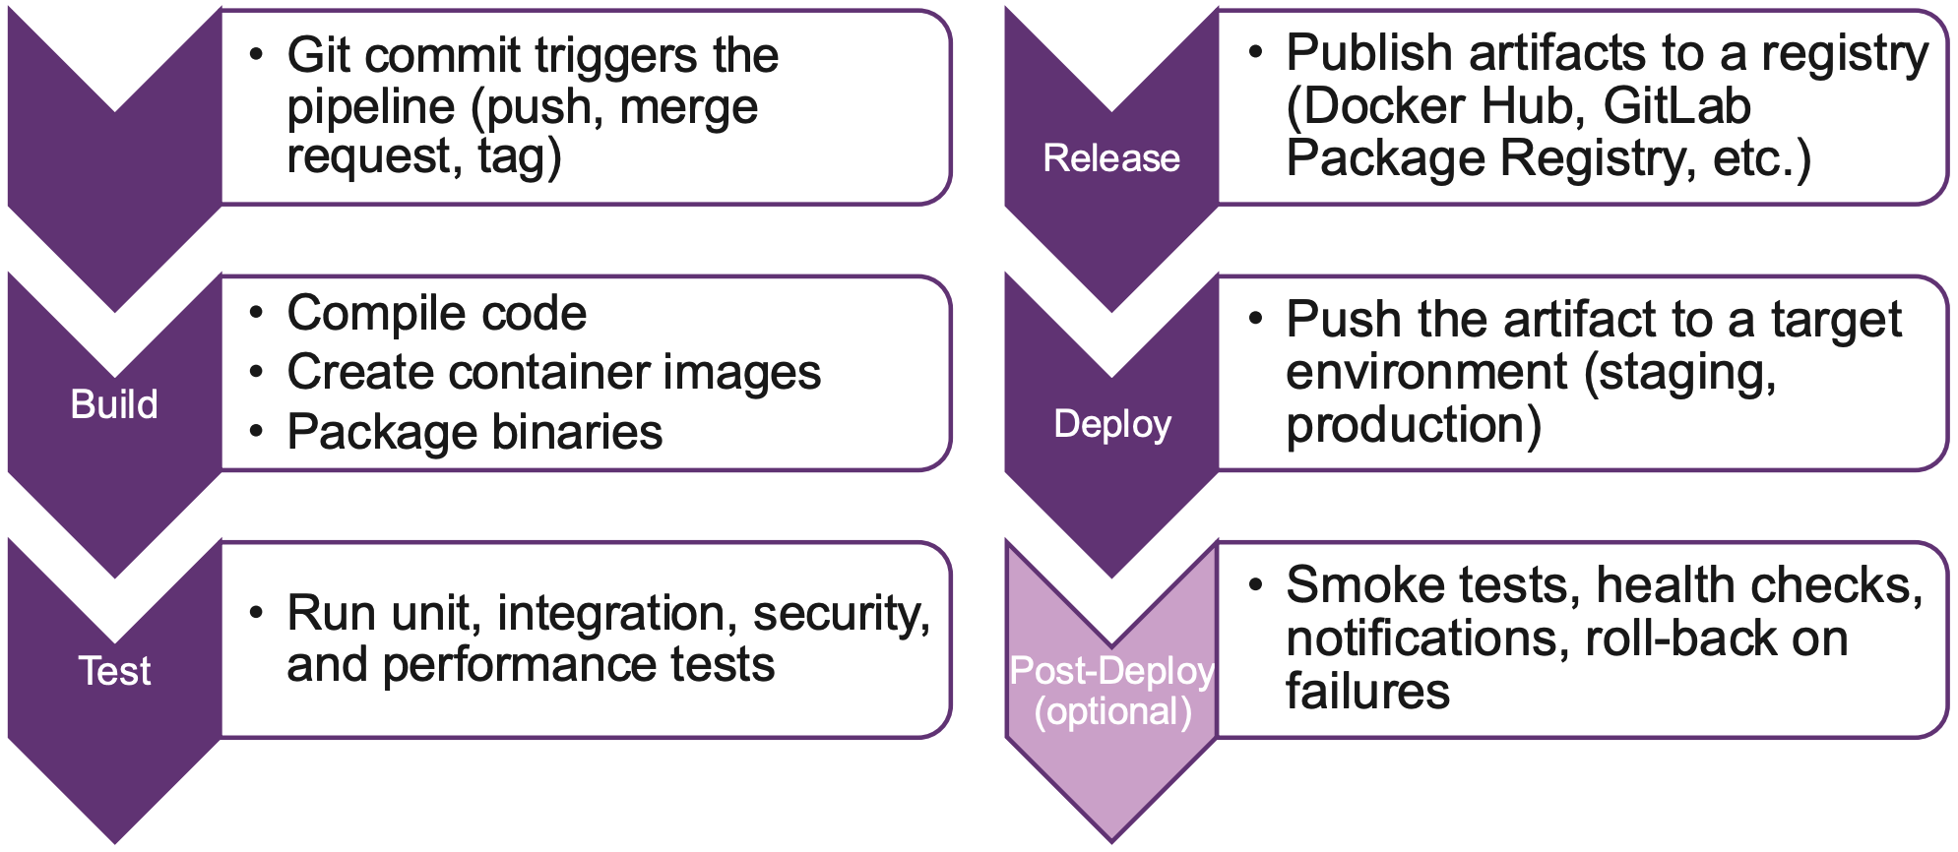
- image: golang:1.0: container image for job
- needs: [“job1”, “job2”]: complex ordering of jobs, ignores stage ordering
- dependencies: [“job1”, “j2”]: for artifact sharing
- Runners: Local shell, SSH, Parallels, VirtualBox, Docker, Kubernetes, Instance or Project
- Typical environments: local, development, integration, testing/QC, staging/pre-prod, prod
stages:  - build  - test  - deploy  build:  stage: build  script:  - echo "x" > artifacts/o.txt  artifacts:  paths:  - artifacts/  expire_in: 1 hour  test:  stage: test  dependencies:  - build  script:  - cat artifacts/o.txt | deploy_staging:  stage: deploy  environment:  name: staging  url: https://staging.ch  on_stop: stop_staging  script:  - cat k8s.yaml | envsubst | kubectl apply -f -  artifacts:  expire_in: 1 hour  stop_staging:  stage: deploy  environment:  name: staging  action: stop  script:  - echo "Stopping staging"

GitOps
Push-based (e.g. Jenkins): triggered by git push, complex drift detection & rollback, easy to use, different targets possible, needs prod admin access, fast, firewall to target must be open, adjustment for new envs needed
Pull-based (e.g. ArgoCD): triggered by agent git pull, automatic change apply, drift detection & rollback, needs prod admin & git access, agent in every cluster needed
4 Core Principles: Declarative,
- Versioned & Immutable: desired state in Git
- Pulled automatically: agent pulls from git
- Continuous Reconciliation: agent continuously observes actual state and attempts to apply desired
Side effects: Documentation & Reproducability

ArgoCD
- Platform Engineering approach, Web UI, CLI
- Best for enterprises, multi-cluster, GUI needed
- Visual dashboard: app health, sync status/history
- Pre- and post-sync hooks for complex logic, granular access control via SSO, built-in health assessment
- App of Apps pattern: keep Applications resources in the Git repo so that they are synced
Key Resources:
- Application: what (which repo), where (cluster & namespace), how (sync policy)
- ApplicationSet: generator that creates multiple Applications based on a template & list of inputs
- AppProject: logical grouping restricts what can be deployed where and who has access to the app

Flux CD
CLI first approach, no GUI, Helm Apps, Gitless GitOps possible (OCI registry or S3 buckets), GitOps Toolkit, Kustomize native, low resource footprint
Key Resources:
- GitRepository / OCIRepository / Bucket / HelmRepository: resource definition sources
- Kustomization: apply manifests / kustomizations
- HelmRelease: apply helm charts

Secrets management
Encrypted secrets: Bitnami Sealed Secrets, Mozilla SOPS, Vault/OpenBao, References to secrets: External Secrets Operator, Secrets Store CSI Driver

Infrastructure Provisioning
- Infrastructure as Code (IaC): managing & provisioning infrastructure through code instead of manually
- Tools: HEAT, AWS CloudFormation, Ansible, OpenTofu, Terraform, Pulumi, Crossplane
- Imperative: How to achieve result, explicit control flow, stateless, not idempotent
- Declarative: What the result should look like, implicit control flow, stateful, idempotent, e.g. OpenTofu

Terraform / OpenTofu
- Open source IaC engine written in Go
- Uses HashiCorp Configuration Language (HCL)
  - Uses { } for blocks and key=”value” for settings
  - Supports simple loops, conditionals and functions
- Linux Foundation’s OpenTofu replaces Terraform
- Workflow: Write *.tf file, tofu {init, plan, apply, destroy}
- Providers: mandatory, translate code into specific cloud API calls, define the building blocks (VMs, DBs, etc.) to use, multi-platform, check if your real-world infrastructure matches code, handle authentication
- Resources: specific infrastructure objects (VMs, DBs, etc.), declare what to create/manage, represent the desired state of a component
- Data: fetch information from existing infrastructure, external reference, uses data not managed by code, e.g. get AWS AMI based on image name
- Variables: dynamic values provided at runtime, allow customizations without changing code, keep secrets and environment-specific data separate, can be set in apply command or Env var, apply command prompts if no default value is set
- Outputs: data displayed after successful deployment, passes data like an IP to the user or other modules, highlights critical resource attributes in the CLI
- References: connects different blocks of code together, dependency mapping, tells which resource to build first, implicit or explicit with depends_on
- State: JSON file mapping code to real-world IDs (e.g. AWS ARN), local file terraform.tfstate, allows to remember what it built previously, identifies if someone manually changed a setting in the console, automatically created first run of apply, 3-way diffs: NEW (code), EXISTING (cloud), PREVIOUS (tfstate)
- Backends: state file should be shared to work in teams, e.g. AWS S3, procedure when someone runs apply: acquire lock from S3, fetch tfstate from S3, update cloud, send updated tfstate to S3
- Modules: templates for reusability, containers for grouping multiple resources together, enforces standardization and best practices
- Recomm. files: terraform.tf, backend.tf, providers.tf, main.tf, variables.tf, outputs.tf, locals.tf, override.tf
variable "instance_type" {  default = "t2.micro"  }  provider "aws" {  region = "us-east-1"  } | resource "aws_instance" "web" {  ami = "ami-0c55b159cbfafe1f0"  instance_type = var.instance_type}  output "public_ip" {  value = aws_instance.web.public_ip }

Configuration Management
- After infrastructure provisioning
- Automate system identification, patches & updates
- Centrally modify base configurations and roll them out to all applicable systems
- Identify outdated, poorly performing and noncompliant configurations
- Tools: Ansible, Puppet, Chef, CFEngine, Juju

Ansible
- Use cases: configuration management, security & compliance, provisioning, application deployment, continuous delivery, orchestration
- No state/shared state/locking/lifecycle
- Declarative & imperative hybrid, idempotency opt.
- Templating, agentless, open source
- Connection via localhost, SSH or WINRM
- Ad-hoc command example:
- Not idempotent: ansible host1 -m command -a “useradd test”
Idempotent: ansible host1 -m user -a “name=test”
Terms:
- Inventory: INI or YAML, list of hosts & variables
- Library: many readily available modules
- Module: unit of code, task plugin, written in Python
- Collection: next-gen modules with version independent of Ansible version, have FQCN
- Role: automatically load related vars, files, tasks, handlers, and other Ansible artifacts based on a known file structure, can easily be shared
- Tag: attribute you can set on an Ansible structure (plays, roles, tasks), execute tasks subset instead of whole playbook
- Task: unit of work (e.g. copy a file), uses a module
- Play: one or more tasks that run in order of definition, defines hosts to run on
- Playbook: YAML file, contains one or more plays
- Facts: Automatic collection of info about hosts when running a playbook, available in ansible_facts variable
- Variables: names should be letters, numbers and _
- Loops: declared below task, some plugins can take lists as options, which is better than looping
- Conditionals: when clause below tasks, raw Jinja2 expressions, can use ansible_facts
- Handler: task that is called by another task, calling task must have triggered a change, executed after all other tasks were successful
- ignore_errors: don’t stop play exec in case of error
- force_handlers: run handlers even if tasks are failing
- Vault: keeps sensitive data like passwords or keys in encrypted files that can be placed in Git, password can be provided via file, prompt or secret manager
- Templating: Jinja2 for dynamic expressions and variables, happens on the Ansible controller, only the information needed is passed to the target machine
- Jinja2 Filters: transform data, e.g. formatting, list filters, random number, math filters, JSON query
- name: Play1 (whole file = playbook)  hosts: web  become: true  vars:  packages: [“nginx”, “curl”]  enable_service: true  secret_pass: "{{ vault_pass }}"  roles:  - myrole  tasks:  - name: Install packages  apt:  name: "{{ item }}"  state: present | loop: "{{ packages }}"  notify: restart nginx  - name: Configure app  template:  src: app.conf.j2  dest: /etc/app.conf  when: enable_service  tags: config  handlers:  - name: restart nginx  service:  name: nginx  state: restarted

Kubernetes
- Open-source system for automating deployment, scaling & management of containerized apps
- Objects: persistent entities, records of intent, represent state of cluster
- Controllers: tracks at least one resource type / object, makes the current become the desired state
- Manifest: declarative YAML to create a resource
kubectl {create|replace|apply} -f manifest.yaml
kubectl get pod x -o yaml --dry-run=client > x.yml
- Pod: smallest deployable unit, represents processes running, contains one or multiple containers
- Sidecar: container in pod that runs concurrently with the main container, provides supporting functionality
- Init container: container in pod that completes a task before the regular container is started
- ReplicaSet: makes sure that we have a specified number of pod replicas running
- Deployment: provides declarative updates to ReplicaSets and Pods (e.g. scaling & update strats)
- HorizontalPodAutoscaler: scales number of pod replicas between minReplicas/maxReplicas based on resource-based/custom/external metrics
- Namespace: logical isolation within cluster, divide resources among users/teams/projects, RBAC policies/ResourceQuotas/LimitRanges per ns, cluster-wide resources like nodes still shared
- Probe types: command exec, httpGet, tcpSocket
- readinessProbe: traffic not routed to pod if it fails
- livenessProbe: restart pod when it fails
- Scheduling: nodeName, nodeSelector, (Anti)Affinity, Pod topology spread constraints, Taints/Tolerations
apiVersion: apps/v1  kind: Deployment  metadata:  name: app  spec:  replicas: 3  selector:  matchLabels:  app: web  template:  metadata:  labels:  app: web  spec:  initContainers: | - name: init  image: busybox  command: ['sh', '-c', 'sleep 10']  containers:  - name: web  image: nginx  ports:  - containerPort: 80  - name: http  image: busybox  command: ['sh', '-c', 'while true; do sleep 30; done']

Update Strategies
- Recreate: all pods are killed and new pods are created, leads to temporary unavailability
- RollingUpdate: updates pods one at a time, maxUnavailable sets the maximum number of pods that are upgraded at the same time, maxSurge sets the number of pods allowed to run beyond the desired number of pods, default is 25% for both

Resource limitations
- Requests: guaranteed min. resources (CPU/RAM)
- Limits: cap before throttling (CPU) or eviction (RAM)
- LimitRanges: sets a range for the requests/limits, also default requests/limits can be set which are automatically added when requests/limits are omitted
- ResourceQuotas: cap total aggregate resource consumption for a namespace

Networking
- Service: provide stable networking for dynamic pods, enable load balancing across multiple pods, label selectors for pods, traffic is routed via kube-proxy to readiness-probe passing pods, DNS resolution within cluster, sticky sessions support, types: ClusterIP, NodePort, LoadBalancer, ExternalName
- Ingress: manage external access to services (HTTP(S)), single entry point for multiple services, ingress controller implements the rules (Nginx, Traefik, etc.), host- & path-based routing, TLS termination, load balancing across services
- Gateway API: Gateway defines entry point (load balancer/controller), HTTPRoute/TLSRoute specifies how to route HTTP/HTTPS traffic to services, advantages over Ingress: standardized across vendors, supports multiple protocols (TCP, UDP, gRPC), fine-grained traffic control, better separation of concerns (infrastructure vs. routing)

Storage
- Volume: used to allocate storage that survives a container & stays available during pod lifetime, can directly bind to specific storage type (e.g. NFS)
- Persistent Volume Claims: decouple pod from requested site-specific storage
- Persistent Volume: defines access to external storage available, PVC searches for available PV that matches, StorageClass can automatically create it
- ConfigMap: store non-sensitive configuration data as key-value pairs, decouple configuration from container images, inject as env vars or mount as files or reference in CLI args, namespace-scoped, can be updated without restarting pods
- Secret: store sensitive data securely, decouple configuration from container images, Base64-encoded, additional configuration for encryption at rest, inject as env vars or mount as files, used by pods pulling private images, access RBAC controlled

Helm
- Package manager for Kubernetes. manages charts and tracks releases, versioned, reusable, sharable, client-side only, communicates with K8s API, state stored in K8s secrets
- Benefits: powerful templating, repeatability, multiple environments, ease of collaboration, huge library of pre-built charts, versioning, dependency management, lifecycle management
- Cons: complex templating, hard to debug/learn, spaghetti YAML risk, opaque state mangement

Core Concepts
- Chart: templates and related files collection describing related resources, can be packages, pushed, pulled and unpacked
- Release: running instance of a chart
- Repository: where the charts are stored/versioned
- Template Engine: Go templates inject vars into YAML
- Values: external configuration passed into templates

Key Commands
helm create <name> # Scaffold a chart
helm install <release> <chart> # Deploy
helm uninstall <release> # Undeploy
helm upgrade <release> <chart> # Update
helm rollback <release> <revision> # Revert
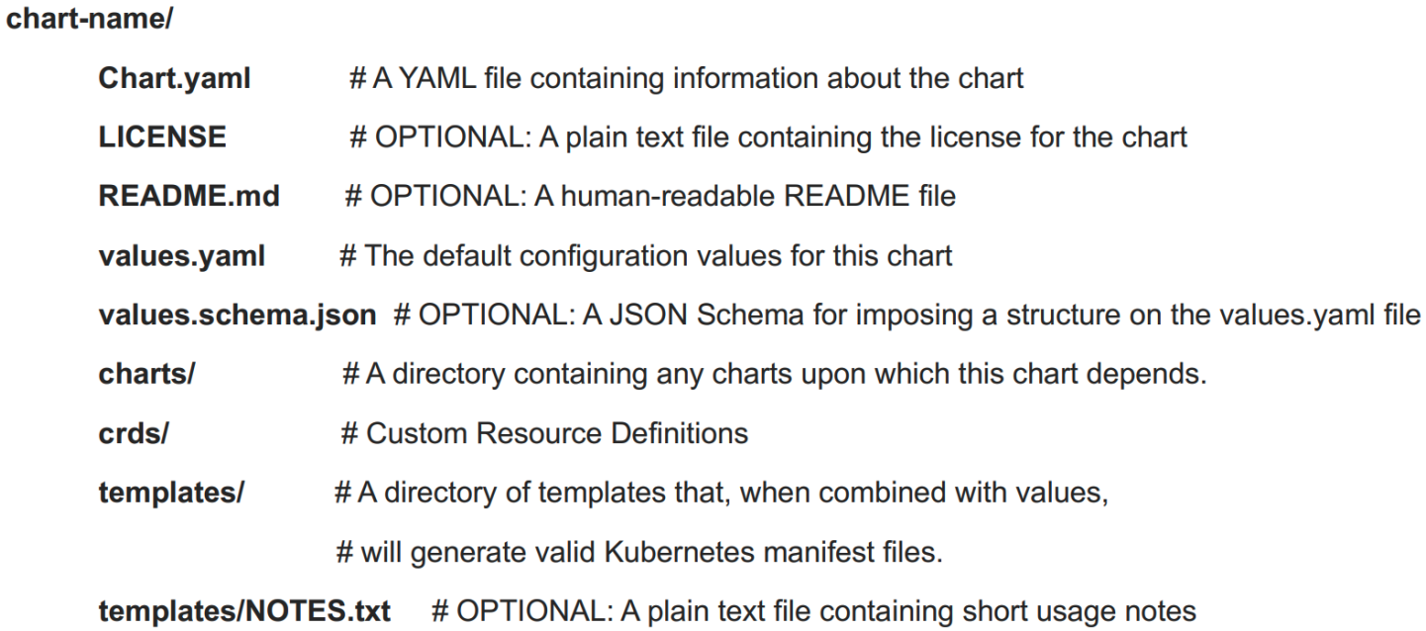

Versions
- apiVersion: v2 for charts needing Helm 3, v1 for older
- version: chart version SemVer2 major.minor.patch
- appVersion: application version, unrelated to chart v.
- kubeVersion: which K8s versions are supported

Pipelines and Functions
- Objects: passed into templates from templating engine, objects can be passed around & manipulated by code, can have many values and functions
- Template functions: allow you to transform data passed into a template, Syntax: function arg1 arg2
- Pipelines: like Unix pipes, allow, chaining, Syntax:
{{ .Values.user | upper | quote }}
- Custom functions defined in _helpers.tpl, required function makes value mandatory, set default in values in default values.yaml or the default function
- if, else, range and with functions available
- Whitespace is important in YAML, therefore we sometimes need to set it with nindent
- Variable example: {{- $rname := .Release.name -}}

Kustomize
- Generate resources from other sources, set cross-cutting fields for resources, compose and customize collections of resources
- Benefits: reusability, fast generation, easy to debug/diff/learn, native to kubectl, pure YAML
- Cons: less powerful than Helm, harder to package/distribute, no dependency management, limited conditional logic
- Creates modified K8s manifests by overlaying declarative specifications over existing manifests
- Changes are stored in kustomization.yaml, simple set of declarations, lists manifests to change
- Transformers are declarative clauses to make changes (labels, namespace, commonAnnotations, namePrefix, nameSuffix, images, etc.)
- Patch: partial spec for a K8s object, describes how a section should be modified, replace or append
- Generator: alternative to creating a manifest for a ConfigMap/Secret, use configMapGenerator or secretGenerator in k.yml, supply name & files/literals
- Components: encapsulates set of modifications, way of defining reusable customization
apiVersion: kustomize.config.k8s.io/v1  kind: Kustomization  resources:  - deployment.yaml  - service.yaml  namePrefix: dev- # transformer  namespace: my-namespace # tf.  commonLabels: # transformer  app: my-app  patches:  - patch: |-  - op: replace  path: /metadata/name  value: nginx-server  target: | kind: Service  name: nginx-app  configMapGenerator:  - name: app-config  literals:  - LOG_LEVEL=debug  components:  - ../../components/mysql  ---  apiVersion: kustomize.config.k8s.io/v1alpha1  kind: Component  resources:  - deployment.yaml  - service.yaml

Key Commands
kubectl kustomize <directory> # View resources
kubectl apply -k <directory> # Apply resources
kustomize build <directory> # Apply modifications
kustomize create –resources <file> # Scaffold k.yml
kustomize edit # Modify k.yml without manual editing
kustomize cfg fmt <directory> # Formats all files

Folder structure
base/ { deploy.yaml | kustomization.yaml | svc.yaml }
{ overlays/ | patches/ }
development/{cpu.yml | kustomization.yml | rep.yml}
production/{cpu.yml | kustomization.yml | rep.yml}

Cilium
- eBPF: makes the Linux kernel programmable in secure and efficient way, like JavaScript for the browser but for the Linux kernel, used by Cilium
- Advantages: performance, security, visibility, stability
- Identity-based security & API-aware authorization
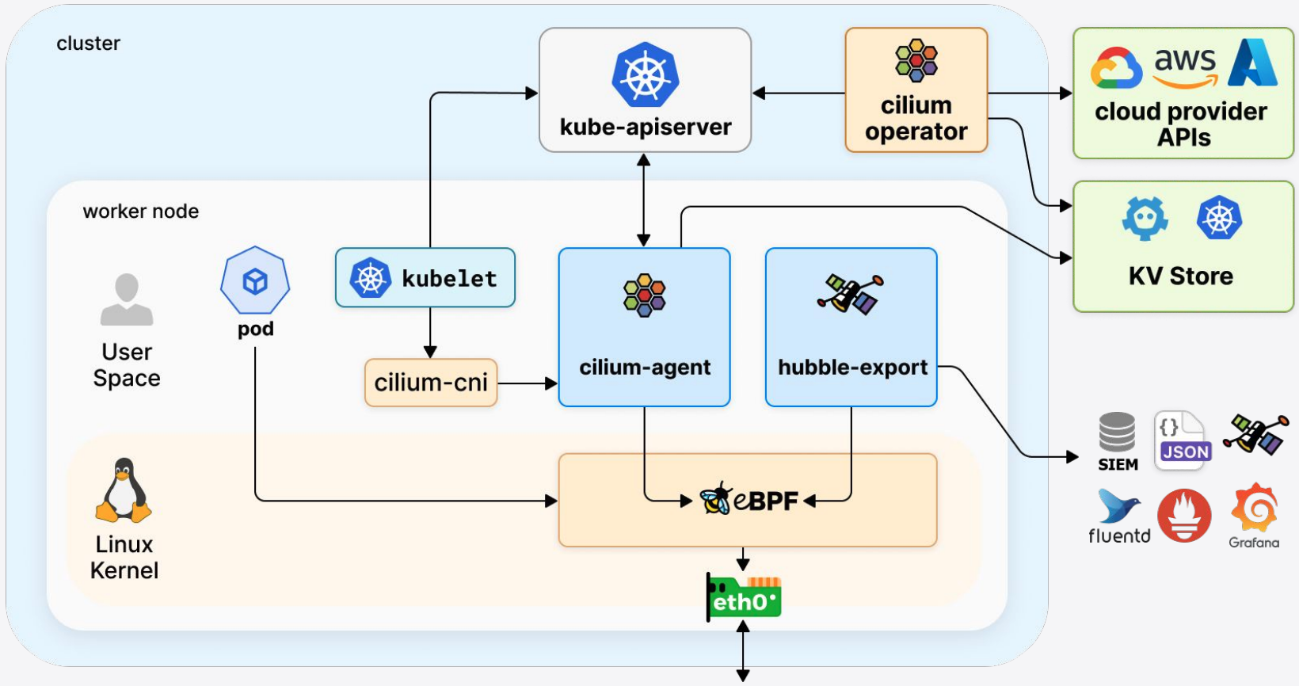

Network Policies
- Declarative Pod-level network firewall abstraction that understands Kubernetes identities
- NetworkPolicy is the K8s built-in resource kind and CiliumNetworkPolicy an advanced CRD
- PodSelector/EndpointSelector: match pods with (multi-) labels, wildcards & set-based label selectors
- Policies are namspaced or cluster-wide (can be influenced with EndpointSelector)
- Ingress rule: traffic entering a pod
Egress rule: traffic leaving a pod
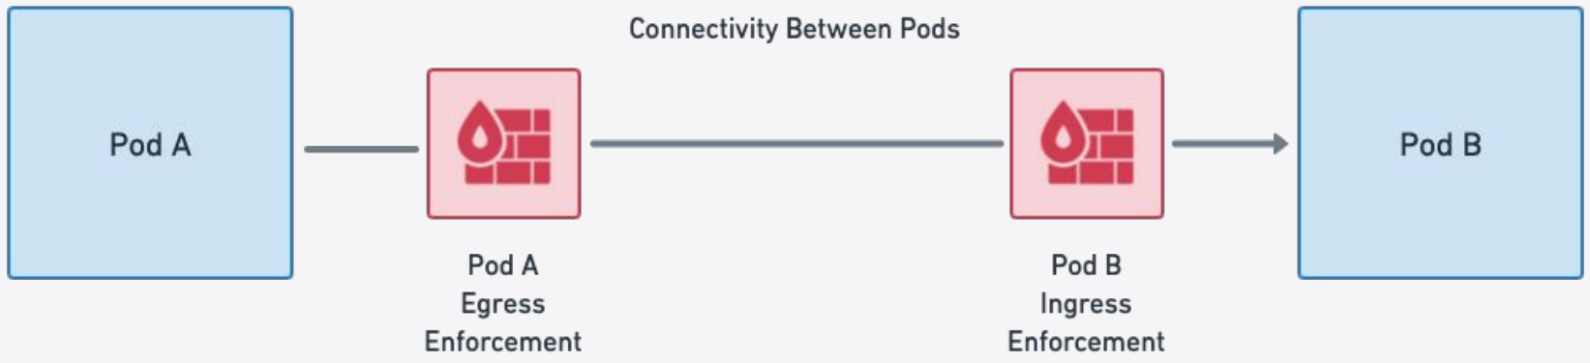
- Default Deny Model: connectivity not explicitly allowed is implicitly denied, stateful connections
- Policy layers: L3 (to/fromEndpoints, to/fromCIDR, to/fromCIDRSet, toFQDN), L4 (to/fromPort), L7 (DNS, HTTP, gRPC, Kafka, Memached, Cassandra), within a rule, each layer is logically AND with the other layers, unspecified layers are wildcards
- to/fromEntities: special reserved L3 identities world, cluster, host, remote-node & kube-apiserver

Hubble
- UI: Service dependency maps, flow display and filtering, network policy viewer
- CLI: detailed flow visibility, extensive filtering, JSON
- Metrics: built-in Prometheus metrics for operations and application monitoring
- Flow metadata: ethernet headers, IP/ICMP headers, UDP/TCP ports, HTTP, DNS, Kafka, ...

Microservices
- App arch style where independent services communicate through lightweight APIs, cloud-native approach
- Pros: independent deployment, flexibility, scalability, fault isolation, team autonomy
- Cons: operational complexity, distributed system challenges, data consistency, possibly higher resource usage, increased testing overhead
- Challenges: load balancing, traffic mirroring, rate limiting, fault tolerance, security, observability, debugging
- Distributed computing fallacies: network is unreliable, latency exists, failures happen

Service Mesh
- Infrastructure layer for service-to-service communication, fine-grained control over routing, traffic splitting, retries, circuit breaking, observability, mTLS, authentication/authorization, resilience, canaries/blue-green/dark launching, rate limiting
- Date plane: lightweight proxies (e.g. Envoy), handles communication, metrics, security enforcement
- Control plane: manages configuration and policies (e.g. Istiod), distributes rules to data plane
- Sidecar downsides: modified K8s pod specs, redirected traffic within pod, large resource requests for worst case, Istio and Cilium available sidecarless (kernel model)
- Gateway API for Mesh Management and Administration (GAMMA) Initiative: use Gateway API not just for north/south but also for east/west traffic

Observability
- Observability: degree to which the system can generate actionable insights
- Why: distributed systems increase complexity, failures are inevitable and can occur at many levels, enabled fast detection or even prevention
- Monitoring: quantitive, metrics, trends (CPU utilization, request counters, error rates, …)
- Logging: qualitative, detailed event records (stack traces, system messages, business events, …)
- Push (agent-based): agent sends signals to collector, observed system decides when to send data, but running an agent is not always possible
- Pull (agentless): collector queries monitored system over an agreed-upon protocol and decides when, observed system must be online all the time

Prometheus
- Open-source metric collector and time-series database, scrapes/pulls metrics from monitored systems at regular intervals via HTTP, push-model also offered with remote-write API or Pushgateway
- Exporters: for servers, for applications, alt. instrumentation with official libraries, custom requests via exporters for services (hundreds available)
- Targets: endpoints to scrape, provide metrics under an HTTP path, configured with scrape_configs in config or dynamically with the Prometheus operator, searches ServiceMonitor /PodMonitors
- Federated Prometheus: e.g. per-region Prom scrapes selected metrics from per-datacenter Prom, other available products are Thanos and Grafana Mimir
- Kubernetes Monitoring: pull-based, targets: kubelets, kube-state-metrics, exporters, Prometheus Operator dynamic targets, Grafana
- Data model: metrics have a name, key-value labels, type (counter, gauge, histogram, summary, etc.)
<metric_name>{<label_name>=<label_value>, ...} <metric_value> [<timestamp>]
- Alertmanager: separates visualization and alerting, GitOps friendly
PromQL:
- Allows the aggregation across labels to analyze metrics (per process/datacenter/service/…), functional, powerful queries for graphs/other visualizations, output is row or graph
sum by(namespace)(changes(kube_pod_status_ready{condition="true"}[5m]))
sum(kube_node_status_condition{condition="Ready",status="true"}==1)

Grafana
- General purpose aesthetic data visualization app
- Works with many data sources including Prometheus
- Integration for identity providers (OAuth, LDAP, …)
- Dashboards: visual summary of system health, custom or pre-built, which many apps provide
- Grafana Alerts: all data sources can trigger alerts, creation of alerts is tied to dashboard, can connect to external alertmanagers, not GitOps friendly, alert routing for larger infrastructure not optimal, supported channels: Mail, Discord, Teams, Slack, Webhooks

Logging
- Container logs to stdout/stderr, logs are ephemeral and tied to the container lifecycle
- Centralized logging is required for historical analysis, full-text search, debugging, forensics
Kubernetes approaches:
- Node level (DaemonSet): pod on each node collects logs of all workloads, works when container dies, batched not real-time, e.g. Fluent Bit, Alloy, Promtail
- App level: push logs directly from within app
- Sidecar: low-latency, logs may be lost when connection breaks, adds complexity to app, doesn’t capture logs in the app crashes, logging agent approach: sidecar exposes logs to stdout, agent sends them to backend, stream approach: sidecar logs to backend

Alloy
- Collects all types of telemetry not just logs
- Configured using its own language Alloy
- Many integrations like Azure, Docker, K8s ,EC2, …
- Logs are enriched with K8s metadata and sent to Loki via HTTP, filtering and relabeling is possible
- Can read logs from files or subscribe to logs via the K8s API (does not need a DaemonSet and root privileges but uses more CPU and generates more traffic)

Loki
- Horizontally scalable log aggregation system with distributed architecture and efficient storage and cost
- Key idea is to index labels not full text
- Tight integration with Grafana
- Query language LogQL like PromQL
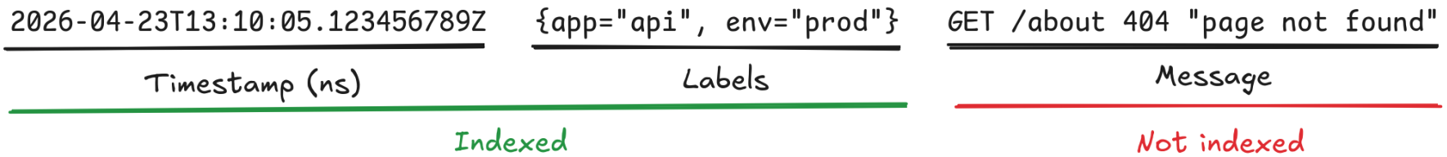
Label filters: = / != / =~ / !~ / > / >= / < / <=
Log line filters: |= / != / |~ / ! ~
{ app = "api" } |= "error"

